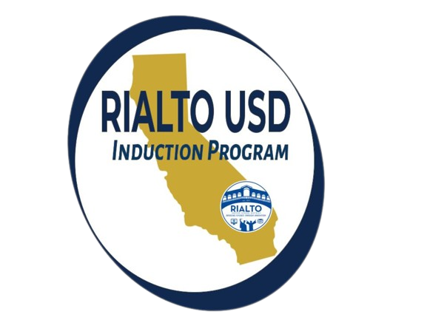 **RIALTO USD Induction Program**

Professional Learning Experiences Log

| Induction Teacher | School Site | School Year |
| --- | --- | --- |
|  |  |  |

| Completed Hours of Professional Learning Experiences (PLE) | | | | | |
| --- | --- | --- | --- | --- | --- |
| * **Year 1** 20 hours - Requires 2 hours of Induction sponsored Professional Learning Experiences * **Year 2** 12 hours - Requires 1 hour of Induction sponsored Professional Learning Experience * **ECO** 32 hours - Requires 3 hours of Induction sponsored Professional Learning Experiences | | | | | |
| **Date of PLE** | **Types of Training**  **OPTIONS:**  🍎 Induction PLE 🍎 Site PLE  🍎 District PLE 🍎 Outside PLE  Please select from the dropdown menu | | **Session Title / Topic** | **Hours** | **Total Hours** |
|
|  | Type of PLE | |  |  |  |
|  | Type of PLE | |  |  |  |
|  | Type of PLE | |  |  |  |
|  | Type of PLE | |  |  |  |
|  | Type of PLE | |  |  |  |
|  | | | |  | **Total** |